Poster title
Logo of home institution

Aim:
- XXXXXXXXXXXXXXXXXXXXXX

Method:
- XXXXXXXXXXXXXXXXXXXX
- XXXXXXXXXXXXXXXXXXXXXXXXXXX
- XXXXXXXXXXXXXXXXXXXXXXX

Results:
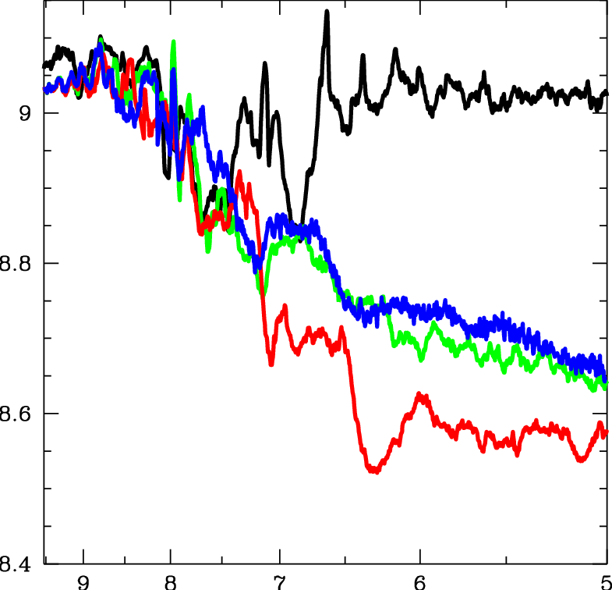

Figure S2: Evolution of the central dark matter phase-space density, F , for small-box simulations with different values of E SN. Black and green lines correspond to the dark-matter-only and hydrodynamic fiducial models (E SN = 0.4 × 10 51 ergs). Blue and red lines correspond to the models with four times lower (0.1 × 10 51 ergs) and four times larger (1.6 × 10 51 ergs) values of the parameter E SN , respectively. Credit: Sergey Mashchenko

