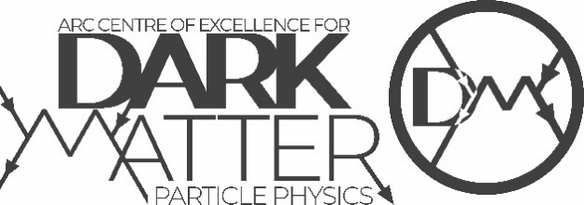
2021 Annual Meeting Poster Session

Welcome to Gather!

Gather will be accessible at any time during the three days of the annual meeting but the user capacity (normally 25 users at one time) will be increased during the poster session which will be after the break on the Tuesday afternoon. You can access the poster session via the following link:
https://gather.town/app/bNLR22adbbsFSpTB/CDM%202021%20Poster%20Session

What you need:
- A desktop/laptop with a mic and camera.
- A web browser (Chrome or Firefox recommended).
- To prevent feedback, headphones are recommended.
- That’s it! There’s nothing to install, no software to download.

How it works:
- Gather is a video chat platform that has avatars move around a map. As you get close to other avatars, your videos will pop up and you will be able to chat.
- Move around the space using the arrow keys.
- By moving your avatar around you can have spontaneous conversations with those around you. These can be either one-on-one or small groups depending on how many people are around your avatar.
- There are ‘private’ spaces where you can interact in a small group.
- When your avatar moves closer to an interactable object, it will glow yellow and there will be a notification that shows up saying ‘Press x to interact with -object’.

For poster presenters:
- Please ensure you create an avatar with your full name so that people can identify you and also find you in the chat function if needed.
- You will need to move your avatar to the relevant room where your poster is located.
- Position your avatar within the small, shaded area (private space) below your poster and be available to answer questions or chat to people that enter the private space and view your poster.
- Make sure you have your camera and mic on.
- Keep an eye on the chat on the left hand side just in case attendees want to ask you a question directly using the chat function.

For other attendees of the poster session:
- Please ensure you create an avatar with your full name so that people can identify you and also find you in the chat function if needed.
- Explore the Gather space by moving your avatar into the rooms that the posters are located.
- View the poster by moving into the shaded area (private space) below the poster and press ‘x’ to view the poster in your full screen.
- If you have your camera and mic on, you can ask the poster presenter questions about their poster.
- If you would like to ask questions via the chat function, find the relevant poster presenter’s name in the chat option on the left hand side of your screen.

Icon explanation:

Chat with individuals by clicking the chat icon (two speaking bubbles) on the left hand side menu and then selecting the name of the individual you wish to chat with.

- Click on your avatar picture to change your avatar character and clothing.
- Click on your name (or on the icon in the left hand menu) to change your name or video/audio settings including testing your audio level input.
- Click on the mini map icon to review the space you’re in.
- Click on the screen to access screen sharing options.
- Click on the smiley face emoji to access emotes that appear above your avatar.

Not-So-Obvious Features:
Here are some things you might find useful but aren't immediately obvious.
- There is a messaging feature that allows you to message people in four ways:
  - individually by clicking on their name in the participant panel,
  - locally to the people you are video chatting with. (“Nearby”)
  - globally to all the people in your map. (“Everyone”)
- There is a locate feature to find others by clicking their name in the participant panel. There is also a follow feature to automatically move your avatar to follow another user. The participant panel is the bottom-most option in your toolbar on the left.
- Interaction distance is also sometimes altered by designated private spaces. This allows conversations to only include people inside that space.
- Want to full screen someone else’s video? Just click on their video.
- Talking to a group of people? Click the box with two white arrows to the right of the video carousel to open the grid view.

Privacy Features:
- Any moderator has the ability to ban individuals during the event
- Any guest has the option to hide a person’s video or mute a person’s audio for themselves only, by using the individual block feature.

Technical difficulties:
- Refreshing the page will fix most things!
- If that doesn’t work, try muting and unmuting your mic and camera in Gather.
- Check if your browser permitted camera and mic access
- Additional troubleshooting at https://gather.town/video-issues

