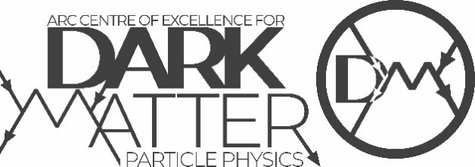
2021 Annual Meeting - Poster Session

1 | Raghda Abdel Khaleq | Sensitivity of Dark Matter-Nucleus Interractions to Nuclear Model Choice
2 | Max Amerl | Searching for low-mass BSM resonances using Trigger-object Level Analysis at the ATLAS Experiment
3 | Ferdos Dastgiri | SABRE Trigger Design
4 | Emily Filmer | One byte at a time: Building the ATLAS Inner Tracker
5 | Graeme Flower | Choosing Dissipative Models for Josephson Junction based Single Photon Counters
6 | Charles Grant | Pixel Cluster Counting for Luminosity measurement
7 | Navneet Krishnan | Simplified Models for Dark Matter Detection
8 | Ben McAllister | The ORGAN Experiment: Current Status, and Future Plans
9 | Lachlan McKie | Development of CYGNUS-1
10 | William Melbourne | Analysis threshold of SABRE South
11 | Markus Mosbech | Easing the σ₈-tension with ν-DM interactions
12 | Zachary Picker | Cosmological Black Holes
13 | Owen Stanley | Development of a low energy event classifier for the SABRE experiment
14 | Sam Thomson | Interaction of Dark Matter with Nucleon Pairs in Stars
15 | Edmund Ting | Overlap Removal using Global Particle Flow at the ATLAS Detector
16 | Tony Tran | Building Things, Measuring Things, then Studying Things: Module Assembly and Track Based Alignment for the ATLAS Inner Tracker Upgrade
17 | Xuan-Gong Wang | Constraints on the dark photon from DIS
18 | Scott Williams | ATLAS-ITK Construction at the University of Melbourne or: An ABCStar module is born
19 | Yiyi Zhong | Cosmogenic background characterization of NaI(TI) crystals
20 | Madeleine Zurowski | Influenceof NaI background and mass on model independent tests of DAMA's modulation

